The Great Trading Path, or the Occaneechi Path
For grades 5-8
Students can view the maps and engage with the thought exercises and discussion questions before reading through the explanation.

Standards:
5.C.1.2 Exemplify how the interactions of various groups have resulted in borrowing and sharing of traditions and technology
5.C.1.3 Explain how the movement of goods, ideas and various cultural groups influenced the development of regions in the United States.
6.H.2.1 Explain how invasions, conquests, and migrations affected various civilizations, societies and regions
6.G.1.2 Explain the factors that influenced the movement of people, goods, and ideas and the effects of that movement on societies and regions over time
6.G.2.1 Use maps, charts, graphs, geographic data and available technology tools to draw conclusions about the emergence, expansion and decline of civilizations, societies and regions
6.E.1.1 Explain how conflict, compromise, and negotiation over the availability of resources (natural, human and capital) impacted the economic development of various civilizations, societies and regions
7.G.2.2 Use maps, charts, graphs, geographic data and available technology tools to interpret and draw conclusions about social, economic, and environmental issues in modern societies and regions.
8.H.3.1 Explain how migration and immigration contributed to the development of North Carolina and the United States from colonization to contemporary times
8.G.1.1 Explain how location and place have presented opportunities and challenges for the movement of people, goods, and ideas in North Carolina and the United States.

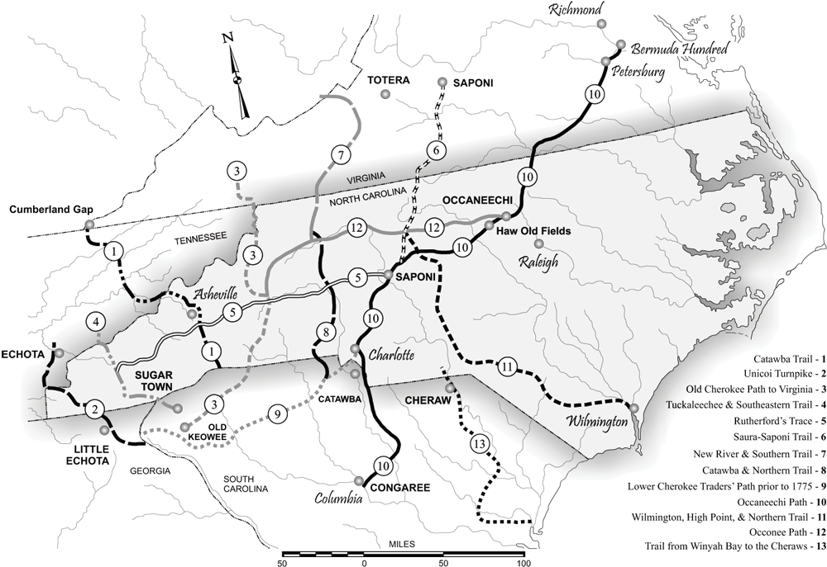
The path labeled number 10 on this map is the Great Trading Path.
Source: http://ncpedia.org/indian-trading-paths
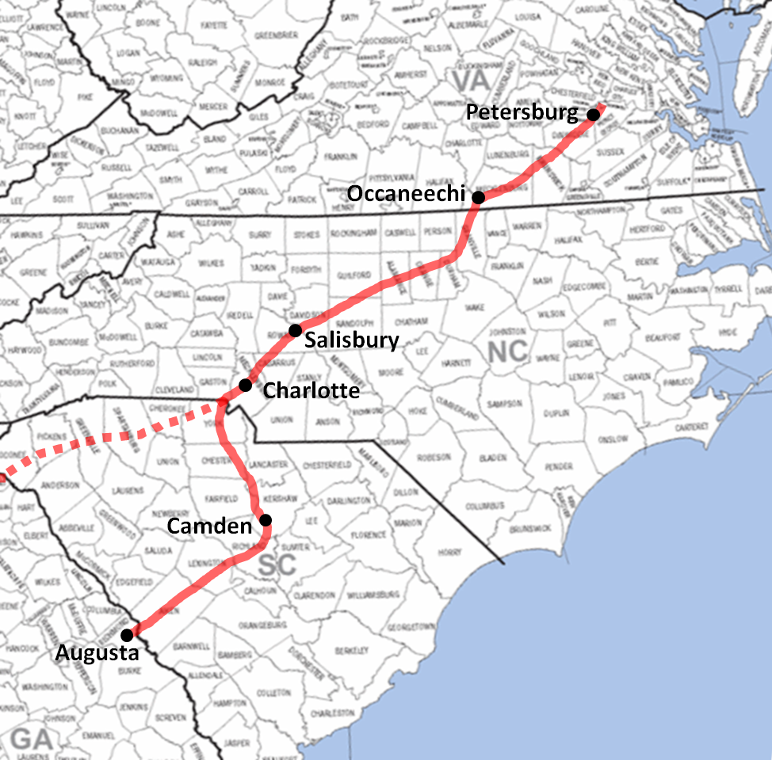
Source: https://familysearch.org/learn/wiki/en/Occaneechi_Path

Discussion Questions/Thought Exercises

- How would life have changed if you were suddenly able to talk with people who lived beyond the mountains, water, or thick forests that bordered your village?
- Look closely at the geographical areas along the way and on each end.
  - What sorts of materials would have been available in each area?
  - What do you see and know about natural resources that helped you come to this conclusion?
- Using your knowledge of Native Americans before Europeans, which tribes do you think this path connected?
- How did the Great Trading Path expand economic opportunities?
- Since this was a pre-established route, how do you think the Europeans reacted to and used it?
- Why might the Occaneechi be reluctant to give up control of the trading path to the Europeans, or any other tribe?
- How would tribal life be different if the path was not established?
  - How would this have changed the way Europeans interacted with tribes?
  - Do you believe the Europeans would have set up their own routes? Why or why not?

Explanation

The Great Trading Path was actually a series of interconnected smaller trails and passages, which then branched into other, established trading paths. It allowed different areas, and people, to be connected. Materials only available in certain areas (such as shells or plants that grew in different climates) were now being seen and used by people who would ordinarily not be exposed to them. Tools could be made with different materials not readily available in the surrounding area. Even cultural practices and artistic expression changed because of this trade; stories and beliefs were shared, and diets expanded with different foods. Tribes were no longer isolated and were able to understand and learn about others.
The main regions connected by the path were the Coastal Plains, the Pediment, and the Mountain region in the western part of North Carolina; some accounts says it began up near Petersburg, VA, and went through to the South Carolina/North Carolina border, or even all the way to Augusta, GA. Shell beads made of conch-which were rubbed smooth and known as Roanoke-from the coastal regions were traded inland, as well as hollies and salt. Hardwoods that would be used for bow making, and the Piedmont region traded various minerals and stone. For example, the Catawba from inland traded skins and mica for fish and salt from the coastal tribes. The mountainous regions mostly provided skins.
The Occaneechi, living along the Eno River, controlled this route. Though each tribe had their own language, those who wanted to trade along the path needed to interact with the Occaneechi. This meant each tribe had to know the Occaneechi: understand their culture, beliefs, and behaviors, and most importantly their language! The Occaneechi language became the unofficial language of the Great Trading Path. Other North Carolina tribes that lived along the path included the Saponi and Tutelo, the Keyauwee (by Caraway Creek), the Sissipahaw (by the Haw River), and the Eno (by the Little and Flat rivers).
When Europeans started moving into the area, they joined up with the Occaneechi to use the path for trading. This was a new evolution in the trading path. Materials that passed along the route changed tremendously; now glass metal, wool, weapons, and liquor were traded. Unfortunately, it was the last two items-guns and alcohol-which contributed to issues within and between tribes. The paths were narrow and winding, moving through thick-forested area. The Occaneechi traveled by foot, which was easier and faster, and did not require you to care for and provide food for another animal. But the Europeans tended to prefer traveling by horse. Because of this, the Great Trading Path was built up and cleared over time to accommodate large groups of horses traveling together. The style of transportation directly influenced changes to the landscape. And it continued to do so; these paths were broadened for wagons to travel through, and many Interstate highways, such as Interstate 85, roughly follow the same route. European migration within North America also followed these routes as they became more established, with towns near major trading posts flourishing.

Further Reading
- Taft Fecher, R. (2008) “The Trading Path and North Carolina”, Journal of Backcountry Studies. https://libjournal.uncg.edu/index.php/jbc/article/viewFile/26/15 [Accessed 9/9/2020].
- Lucas, K (2015) ‘ Geography of Granville County and Regional Native American Site’. https://nativeamericanroots.wordpress.com/tag/great-trading-path/ [Accessed 9/29/2020].
- Davis, Dr. R.P.S. (2006) ‘Great Trading Path’. https://www.ncpedia.org/great-trading-path [Accessed 10/2/2020].

