**Orange County Historical Museum Gallery Guide**

**History of the Orange County Historical Museum**

* As part of Hillsborough’s Bicentennial in 1954, the Hillsborough Garden Club displayed historical artifacts from local families in Orange County’s Old Courthouse.
* From that event, and with the Garden Club leading the effort, the Museum opened its doors in November 1957 at the Old Courthouse. The Museum moved to its current location in 1983.
* Concurrently, the Hillsborough Historical Society was founded in 1962. It championed buildings to be included in the National Register of Historical Places, gave historic walking tours, and published newsletters and journals.
* In May 2007, the OCHM merged with the Hillsborough Historical Society to form the Historical Foundation of Hillsborough and Orange County, a 501(c)3 non-profit organization.
* Today, the OCHM serves to highlight and preserve Orange County’s unique history through its exhibits.

**Gallery Map**

**History of the Museum building:**

* The corner of North Churton and West Tryon streets in Hillsborough was originally demarcated as Lot 98 in William Churton’s 1754 survey of the town. St. Matthew’s Church, the Anglican parish church for Orange County, was the first building on the lot.
* In 1788, the building became the site for the NC Constitutional Convention.
* The property came into the possession of the Presbyterian Church in 1797, and a church building was erected on the site in 1816, with a Session House added at the corner of the property in 1836.
* In 1934, a new library was built on the site as a U.S. Works Progress Administration (WPA) project. Funded by the Daughters of the Confederacy, the words “Confederate Memorial Library” were placed in the gable of the front portico.
* In 2015, the Town Council voted to remove these words after the mass shooting in an African-American church in Charleston, SC, by a white supremacist. The vote reflected the Museum’s wishes to be inclusive in nature and support the telling of diverse stories of all residents of Orange County.

**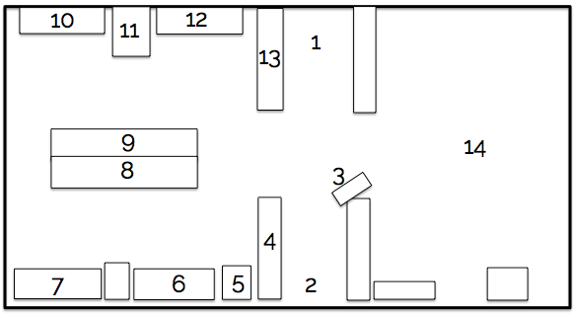**

1. Entrance

2. Front Desk

3. Gift Shop

4. Indigenous Culture

5. Occaneechi

6. European Settlement

7. Colonial Weights and Measures

8. Regulators and Revolution

9. Civil War

10. Rip Van Winkle

11. Wash Day

12. Reconstruction and Growth

13. Modernization

14. Special Exhibits

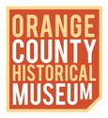

**Orange County Historical Museum**

201 N. Churton Street, Hillsborough, NC 27278

919-732-2201 \*\* [www.orangehistorync.org\*\*@orangehistorync](http://www.orangehistorync.org**@orangehistorync)

***The mission of the Historical Foundation of Hillsborough and Orange County is to enlighten and engage our community and visitors from around the world by preserving and interpreting the history of Hillsborough and Orange County.***

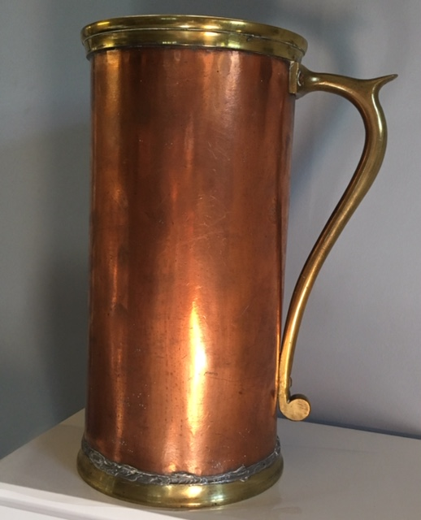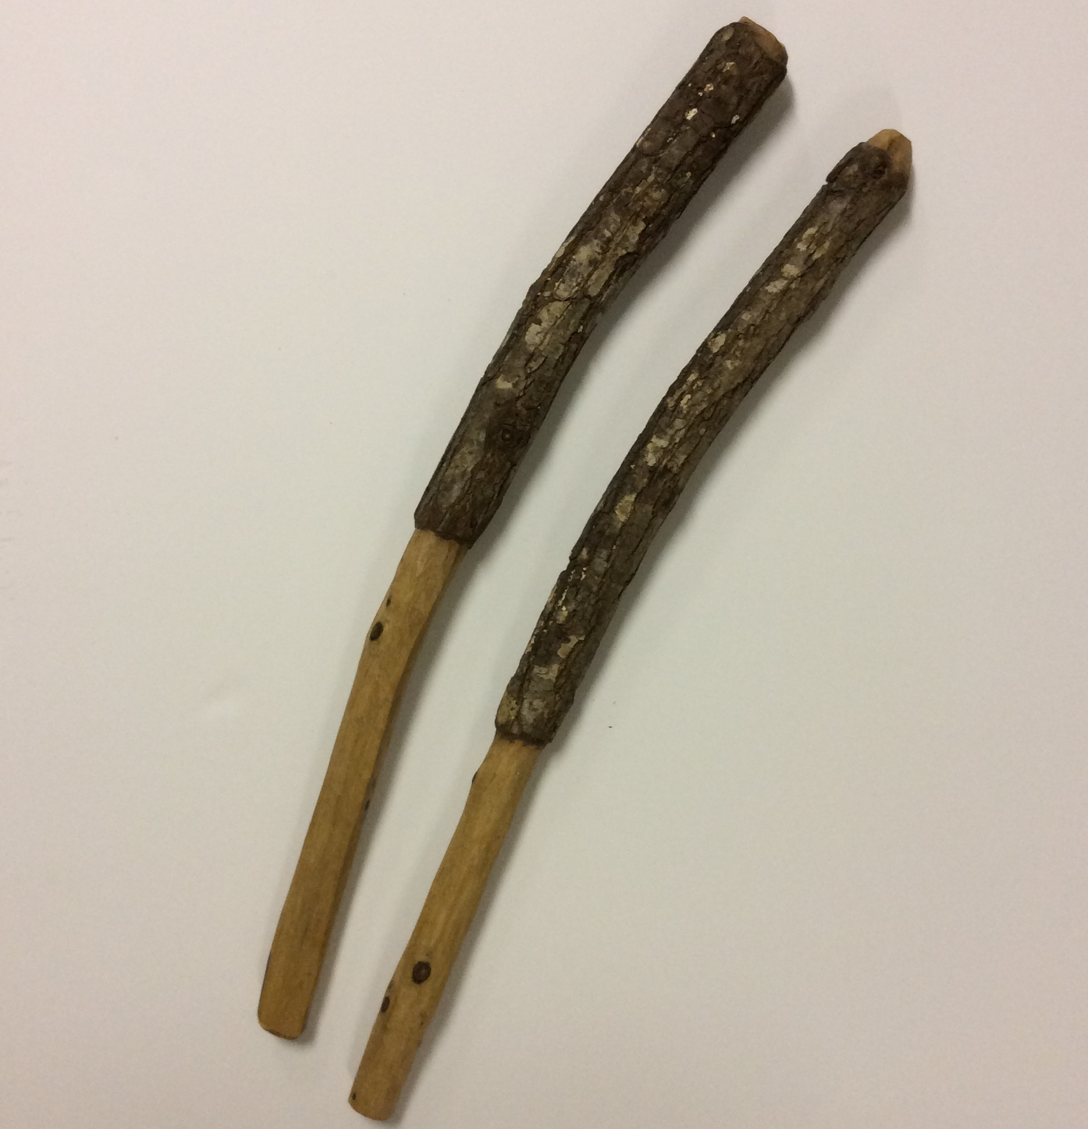**Can’t Miss Items**

These curved rabbit hunting sticks are an ancient technology passed down through generations since prehistoric times.

The only complete set of Colonial Weights and measures in the United States! Originally purchased for Orange County in 1760.

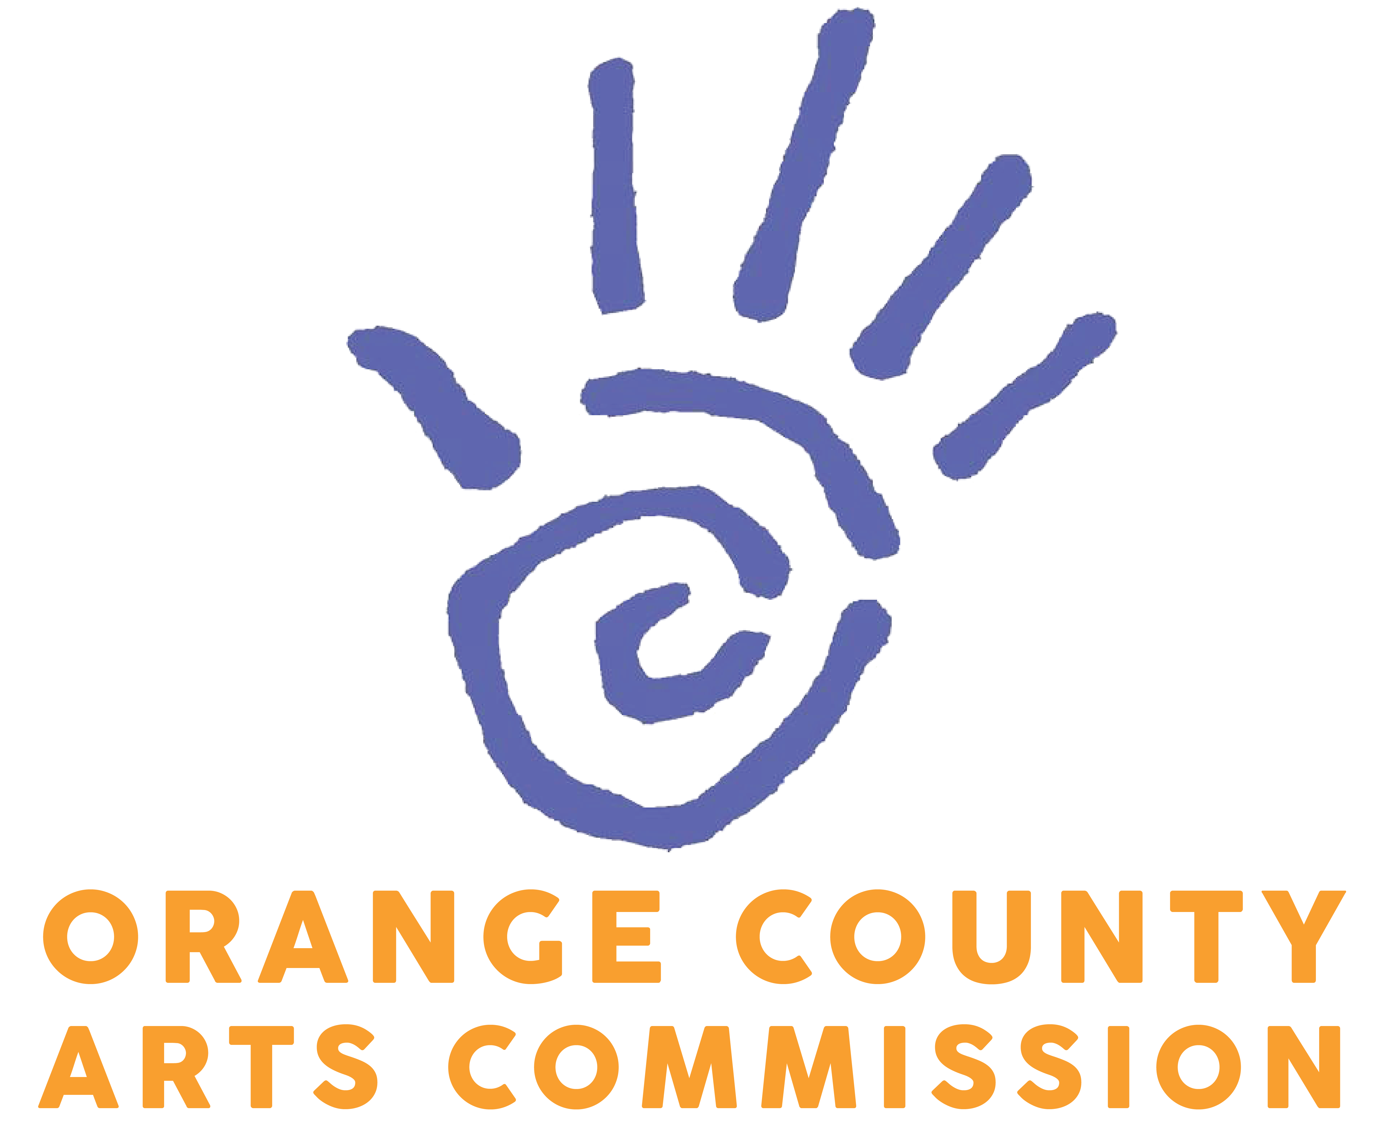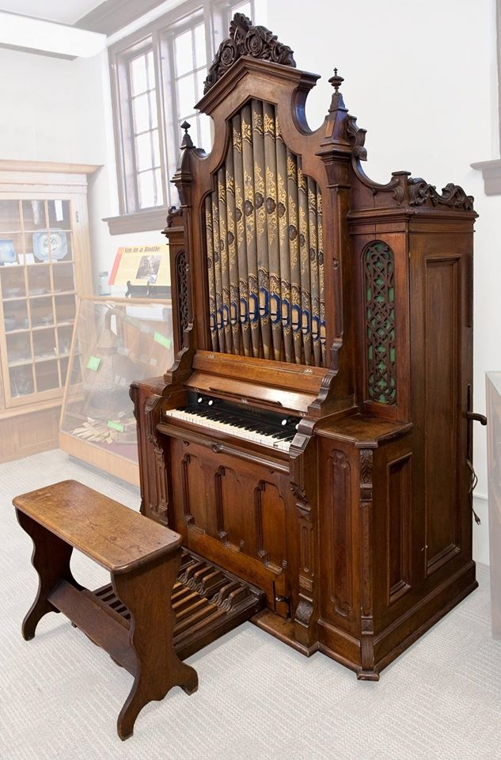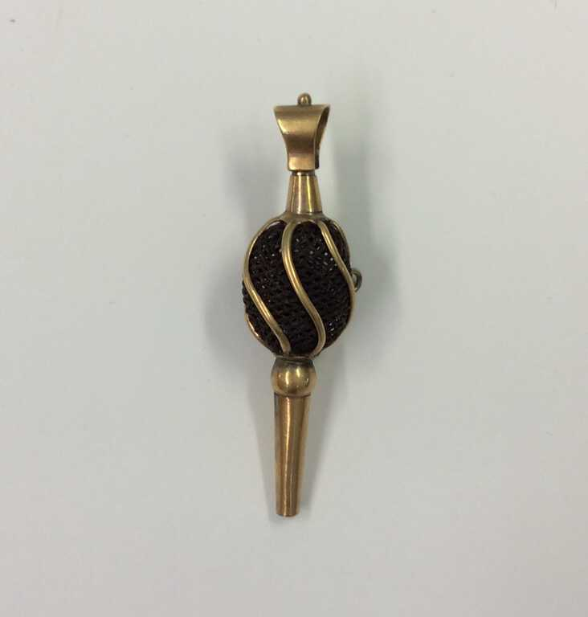

Theresa Joniec

Annette Jurgelski

Renee Keogh

Denise Kilmas

Vicky Kruckeberg

Mary Leb

Madeline Levine

Barbara Martin Lipscomb

Andrew Logue

James Lynch

Tom Magnuson

Pip Merrick

Alice Moore

Thierry Murad

Diane Nelson

Ken Ostrand

Carolyn Parker

Michael G. Parker

Anne Parks

Jim and Carolyn Parsley

Beverly Payne

Gail Perry

Carolyn and Gary Peterson

Eric Peterson

Nancy Powell, MD

Mr. and Mrs. William M. Ross

Anne Rutledge

Sharon and Jerome Schiro

Richard Shaw

Roger Smith

Ann Spurrier

Kevin Swain

Jenn Sykes

Ron Thorn

Loveta and Debbie Todres

Donald Von Hagen

Liz Waters

Ron Weisenfeld

Christine Wynd

Antonia’s Restaurant

Samuel Anderson

Sherry Appel

Jeffery Beam

Leandra Bedini

Barbara Bergen

Blackbaud Giving Fund

Tonya Brami

Emma Broussard

Nils Brubaker

Betsy Burnette

Nicolette Cagle

Candice Cobb

Chris, Amy, and Jay Cole

Anna Currie

Deborah Dallas

Steven Daniels, DDS, PA

Elizabeth and James Davis

Trish and Dan Dennis

Glenn and Lizzie Dicker

Marguerite Dingman

Betty Eidenier

Jay Enterkin

Kathleen Ferguson

Karen Fowler

Selene Friend

Jasmyn Fritz

Sarah Geer

Susan and Dr. Martin Giesecke

Eric Gilmore

Chris and Brooks Graebner

Nancy Haines

Tracy Heron-Moore

Dean Herrington

Hillsborough Garden Club

Wendy Hamilton Hoelscher

Tiffany Hulett

Hon. Verla Insko

Robin and Barry Jacobs

Kathleen Johnson

**Thank You to our Donors and Sponsors!**

*We appreciate your generous support*

This ornate organ was created in 1830, and was used extensively by the Presbyterian Church throughout the 19th and 20th centuries.

A decorative watch winder created to hold a small ball of hair. Making and receiving hair jewelry (to show devotion to a beloved or mourn someone’s passing) was a popular part of mid-1800’s culture and industry.

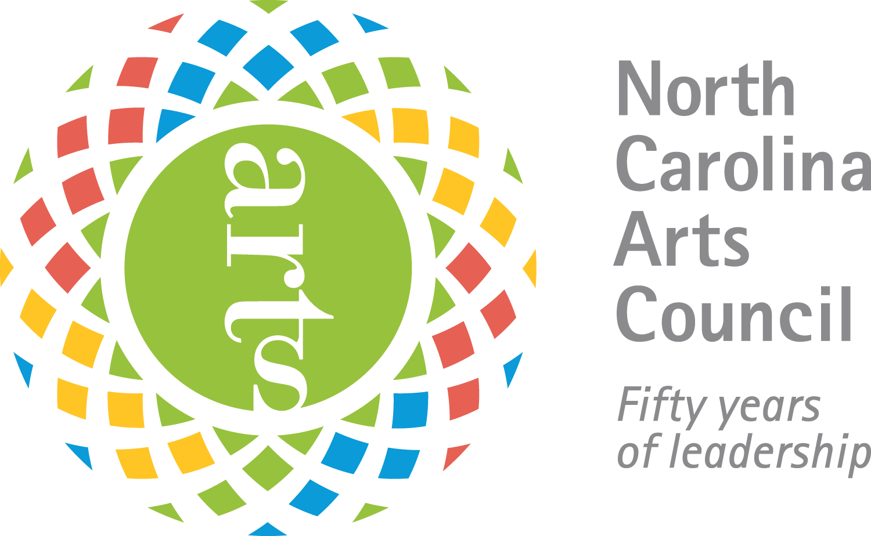

system:Users:frontdesk:Desktop:Donors:Donations FY 21-22:Major Donors_sponsors FY 21-22:Leeland Little Logo.pdf



system:Users:frontdesk:Desktop:Active Grant Work:NCH-Logos-Vector:NCH-MainLogo-4Color_wTagline.eps