You’re the Curator!

GRADE LEVELS
- Suggested for grades 3 and up
- Modifications and scaffolding can provide a more challenging and engaging version for older students
SKILLS ADDRESSED
- Narrative, creative, and non-fiction writing
- Building connections between topics and materials
- Communicating a meaning clearly verbally and through written text
- Using interdisciplinary approaches towards a project for a holistic and thoughtful product
CURRICULUM STANDARDS
Arts
- 3,4,5,6.V.1 Use the language of visual arts to communicate effectively.
- 4,5,6.V.3 Create art using a variety of tools, media, and processes, safely and appropriately.
- 4,5,6.CX.2 Understand the interdisciplinary connections and life applications of the visual arts.
- 4,5,6.CR.1 Use critical analysis to generate responses to a variety of prompts.
ELAR
Writing Standards
- 3,4,5,6.2 Write to share information supported by details.
- W.3.5 Conduct short research projects that build knowledge about a topic.
- W.4.5 Gather information about a topic from two or more sources for a research project.
- W.5.5 Conduct short research projects that uses several sources to build knowledge through investigation of different aspects of a topic.
- W.6.6 Gather information from multiple print and digital sources that relates to a given topic.

Speaking and Listening Standards
- SL 3,4.4 Report on a topic or text, tell a story, or recount an experience in an organized manner, using appropriate facts and relevant, descriptive details to support main ideas or themes; adjust speech as appropriate to formal and informal discourse.
- SL.5.4 Report on a topic or text or present an opinion, sequencing ideas logically and using appropriate facts and relevant, descriptive details to support main ideas or themes; adapt speech to a variety of contexts and tasks.
- SL.6.4 Communicate findings including descriptions, facts, or details related to main idea or theme.
- SL. 5-6.5 Include multimedia components and visual displays in presentations to clarify information.

VOCABULARY
Museum: A building where interesting and important artifacts (items or objects) of history, science, art, and culture are stored and exhibited to the public.
Exhibit: An organized presentation and display of artifacts and ideas.
Curator: A person in charge of museum artifacts, collections, and exhibits.
Narrative: A series of related events, experiences, and information that together tell a ‘story’, nonfiction or fiction.
CROSS-CURRICULAR APPLICATIONS
Art: Use different artistic techniques or mediums when designing and presenting your exhibit, such as the use of collage, sculpting a diorama, pastels or watercolors, or charcoal drawing and shading.
History: Research the three items and show that you understand their meaning, use, and significance in the item text.
Mathematics: You have a budget of $500 for this exhibit. Assign a price to each text panel printed, the use of certain colors for designing, and the purchasing of different kinds of display stands (various case shapes, sizes, and materials).
Foreign Language: Write bilingual text for your introductory panel and individual items.

ACTIVITY
The following pages contain information that can be printed and used in the classroom or presented in person, depending on whether Museum staff is leading the activity (on-or off-site) or if the teacher is modifying the activity for their own purposes.
If led by Museum staff, the staff member will talk through the background information and present 3-4 collection items for the students to create exhibits about. Students will closely examine these items (but not touch, unless instructed by Museum staff), before writing their own text and drawing their exhibit design.
As a whole group, pages 4-6 containing background information can be read and/or discussed. In small groups, students complete pages 7-8. When finished, they can present their exhibit to the class!
Alternatively, see pages 9-16 for photographs of various items that could be used if this lesson is done virtually and/or without Museum staff.
MODIFICATIONS

- Create dioramas of the exhibit, using paper drawings, clay models, or other found objects to represent the collection objects
- Use objects found at home or around the school as the items
- Students can work alone instead of in groups
- Students can dictate text to a teacher or helper
- Students may type instead of handwrite their text
- Students may create a digital version of their artistic rendition, for example with PowerPoint or even in Minecraft

What is a curator?

A curator is a person who works for a Museum or other cultural place. There are many people that work at museums, from educators and guest helpers to finance managers or building operators. But the curator is usually in charge of taking care of the collections and designing and presenting exhibits. The collections are all of the artifacts, important objects and documents that the Museum has on display or in storage. The exhibits are displays that present the artifacts to guests.
Curators often have a chance to choose special artifacts that they think guests will find interesting. But, there is not always something interesting about just an old shoe, for example. It is the curator’s job to do research, write text, and design fancy presentations in order to make that old shoe super duper interesting, and teach guests about why it is interesting or important.
Curators and Museums are very important to the community. They are people and places that take care of interesting and important things that tell the story of humans from the past and even of today. Museums make you think about life in ways you may never have thought about before, and are places where you can learn about new things. By taking care of, and exhibiting, these artifacts, Museums hope to save objects and ideas for as long as they can, so that someday people hundreds of years in the future can still be learning about and enjoying them.

Step 1: Choose your items!
How does a curator plan an exhibit?

Exhibits show all sorts of things, big and small, flat and three dimensional, old or even new. What matters is that the things are interesting, or have an interesting story to tell. After a curator has chosen their artifacts, the items or objects that they will display, they have to come up with a way to tell that story.
Step 2: What’s my narrative?
First they develop their overall narrative- a story that the items can tell. Here are some examples:
  - A projectile point (like an arrowhead), a deerskin, and some corn could tell the story of indigenous life before Colonization.

  - An old map, a car tire, and a sign from a 1950s gas station could tell the story of family road trip vacations in North Carolina during the mid-20th century.

  - A diary, a dress, and a toy could help tell the story of a young girl’s life.

Step 3: Title Time!

After the curator has chosen their narrative, they come up with a catchy title for the exhibit:
  - Indigenous Life Along the Eno River

  - Buckle Up!

  - Carusa McFrillypants: Mistress of Monstrous Mystery?

Step 4: Introductory Text

Once the curator has decided on their narrative and exhibit title, they write introductory text. Introductory text tells the visitors what the story is, and what the exhibit is about. This text is usually only one paragraph long. It is printed out in large letters, and hung at the very beginning of the exhibit. This way, people can read what the exhibit is about before they enter and explore the exhibit space. Introductory text can be anywhere from one sentence to a couple paragraphs long, depending on how complicated the narrative is. Here are some examples:
  - Hundreds of years ago, indigenous peoples, like the Occaneechi Band of the Saponi Nation, lived and thrived along the shore of the Eno River. Let’s take a look at what their life was like.

  - Cramped back seats, juicy hamburgers, and awkward family photos! Take a road trip back in time and relive the memories of a classic American 1950’s highway driving vacation!

  - Carusa McFrillypants was just an ordinary girl…or was she? Explore some of her belongings and diary entries, and decide for yourself: was she just like any other 10 year old, or was she secretly a spy for the forest fairy council?

Step 5: Item Labels

Next, each item in the exhibit needs a sentence to describe what it is and how it fits into the narrative, or tells the story. These are called item labels, and usually each piece has its own label. Item labels are usually only one or two sentences long.

  - This projectile point was created using flint found along the banks of the Eno river, and was an important tool for the Occaneechi who used it to hunt, cut wood, scrape animal hides, and even protect themselves.

  - This rusty sign for ‘Jameson’s Oil N’ Snax’ may not seem like much, but for many families traveling for hours along Interstate 40, it was a beacon of hope as it promised fuel for both the car and the kids—and the cleanest bathroom for miles around!

  - Carusa’s diary is bound in beautiful leather, which most journals of the time were. But if you look carefully you’ll notice that the leather used here has an eye-catching iridescent hue, as if it was dipped in oil or came from a strange mythical beast.

Step 6: Design and style!

When the curator has chosen their items, decided on a narrative, and written the text, they then have to decide how the exhibit will look.

- Where and how will the items be displayed?
  - Together, or in different cases?
  - Will the items be placed on top of a box, or lay flat?
- What sort of colors will be used on the walls, the cases, and for the text?
- What font will the text be written with?
- Will there be any special lighting or sound effects and music?
- What about using interesting designs, like stickers on the floor or large photographs on the walls?

Curate Your Own Exhibit!

Narrative Planning and Text Writing: You must use the provided items to curate your own exhibit! The questions below will help guide you through the curating process.
- What is the narrative/story that these items will be telling? What is our exhibit about?

- What is our exhibit title?

- Write 2-3 sentences of introductory text that tells the overall story of your exhibit which guests would read as they enter your exhibit

- Write 1-2 sentences describing each item and how it connects with and tells the overall story
First Item:

Second Item:

Third Item:

Exhibit Design
Now it’s time to create an artistic design of your exhibit!
- Write your exhibit title on the top of your page (you can make it as fancy as you would like!)

- Write your introductory text somewhere on the page, perhaps on the top, bottom, or along the sides of the paper

- Draw your three items in the way you would like them to be displayed (don’t be afraid to get creative--sometimes curators will even hang their items from the ceilings!)

- Write the item text under, beside, or near each item
- Feel free to draw any interesting details, like wall or floor decorations, or to show if you have special lights, music, or videos playing

ORANGE COUNTY HISTORICAL MUSEUM ITEMS

Here are photographs of some of the Museum collection items that could be used for this activity if done off-site and/or without Museum staff. Each item here has a short description; however, it is not necessary for students to know what each item is, as this could result in more interesting projects and thought processes!

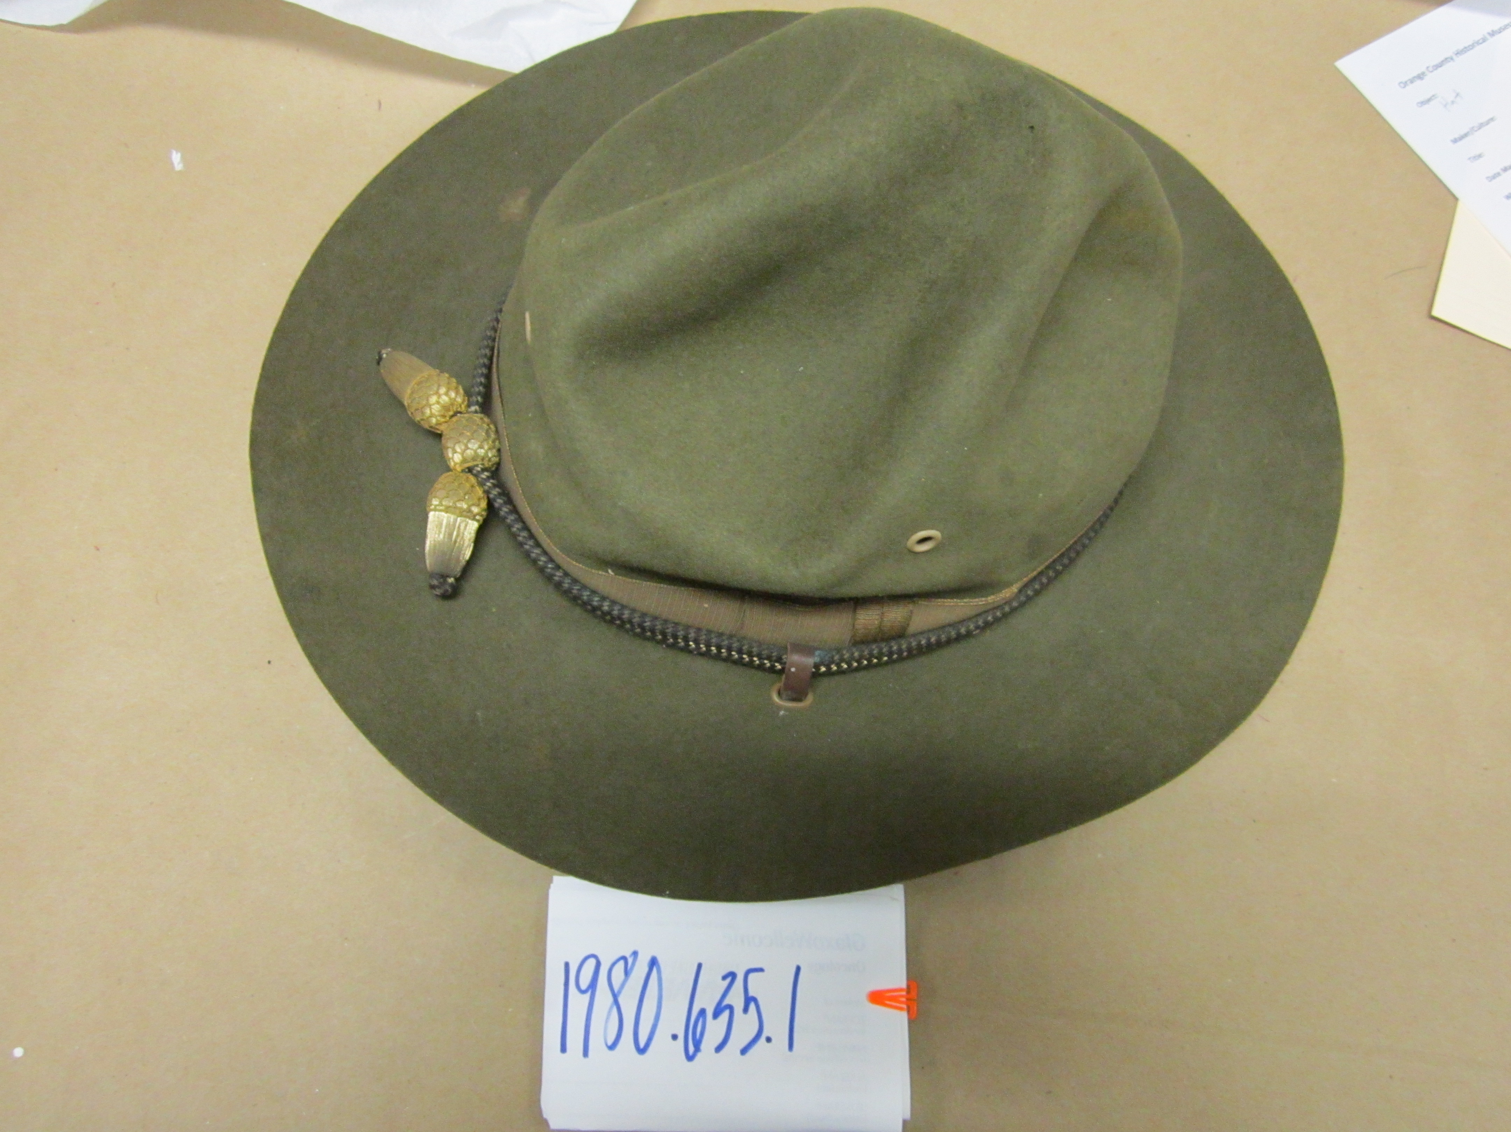
World War 1 Officer Hat

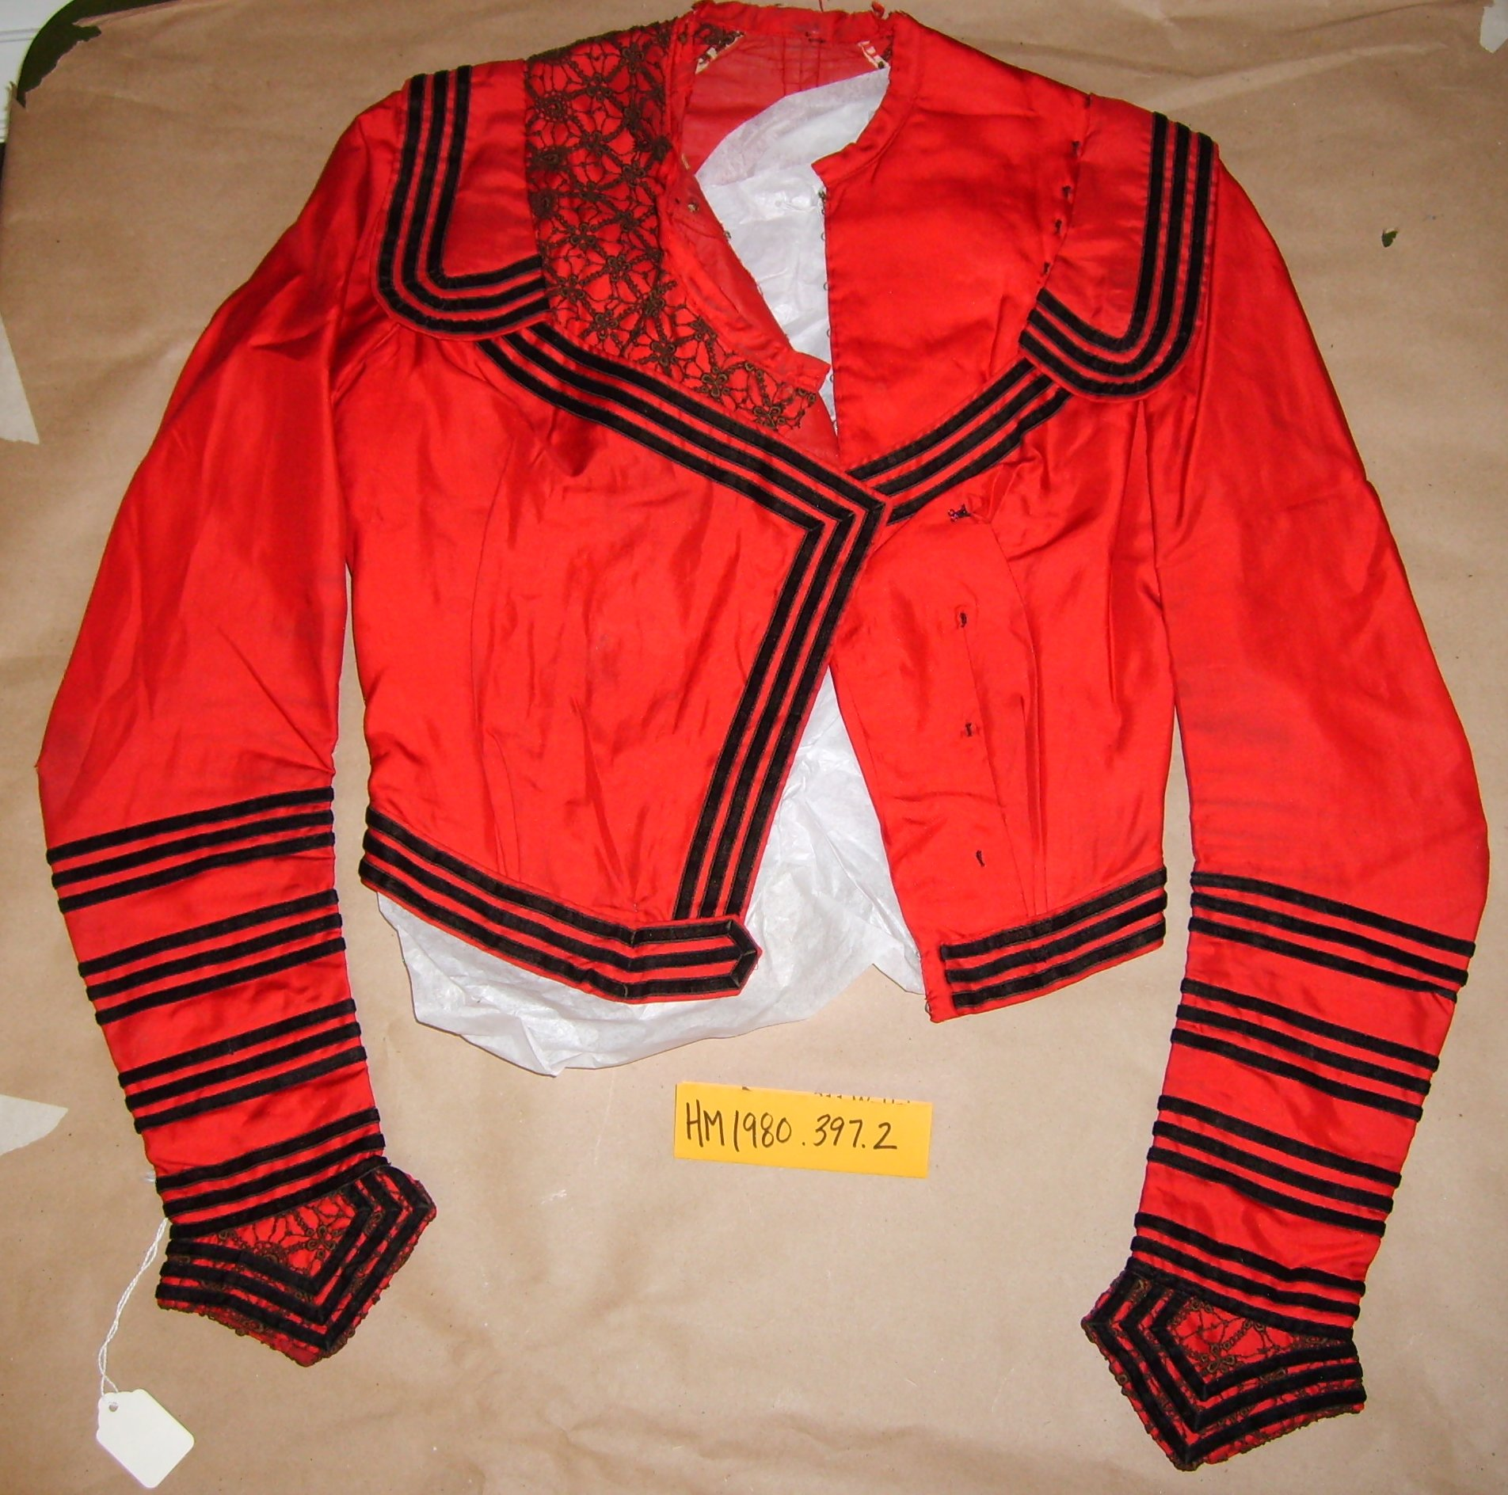
Red silk blouse, c. 1870-1900

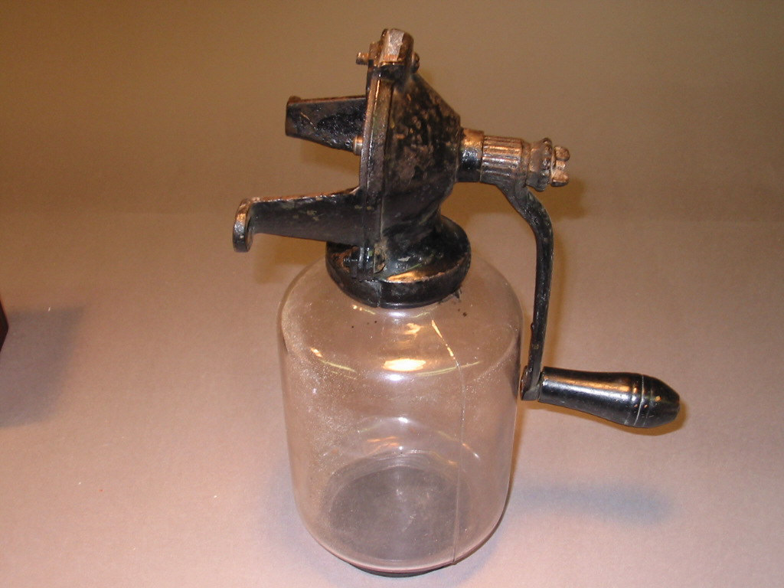

Apple butter stirrer (missing a cog)

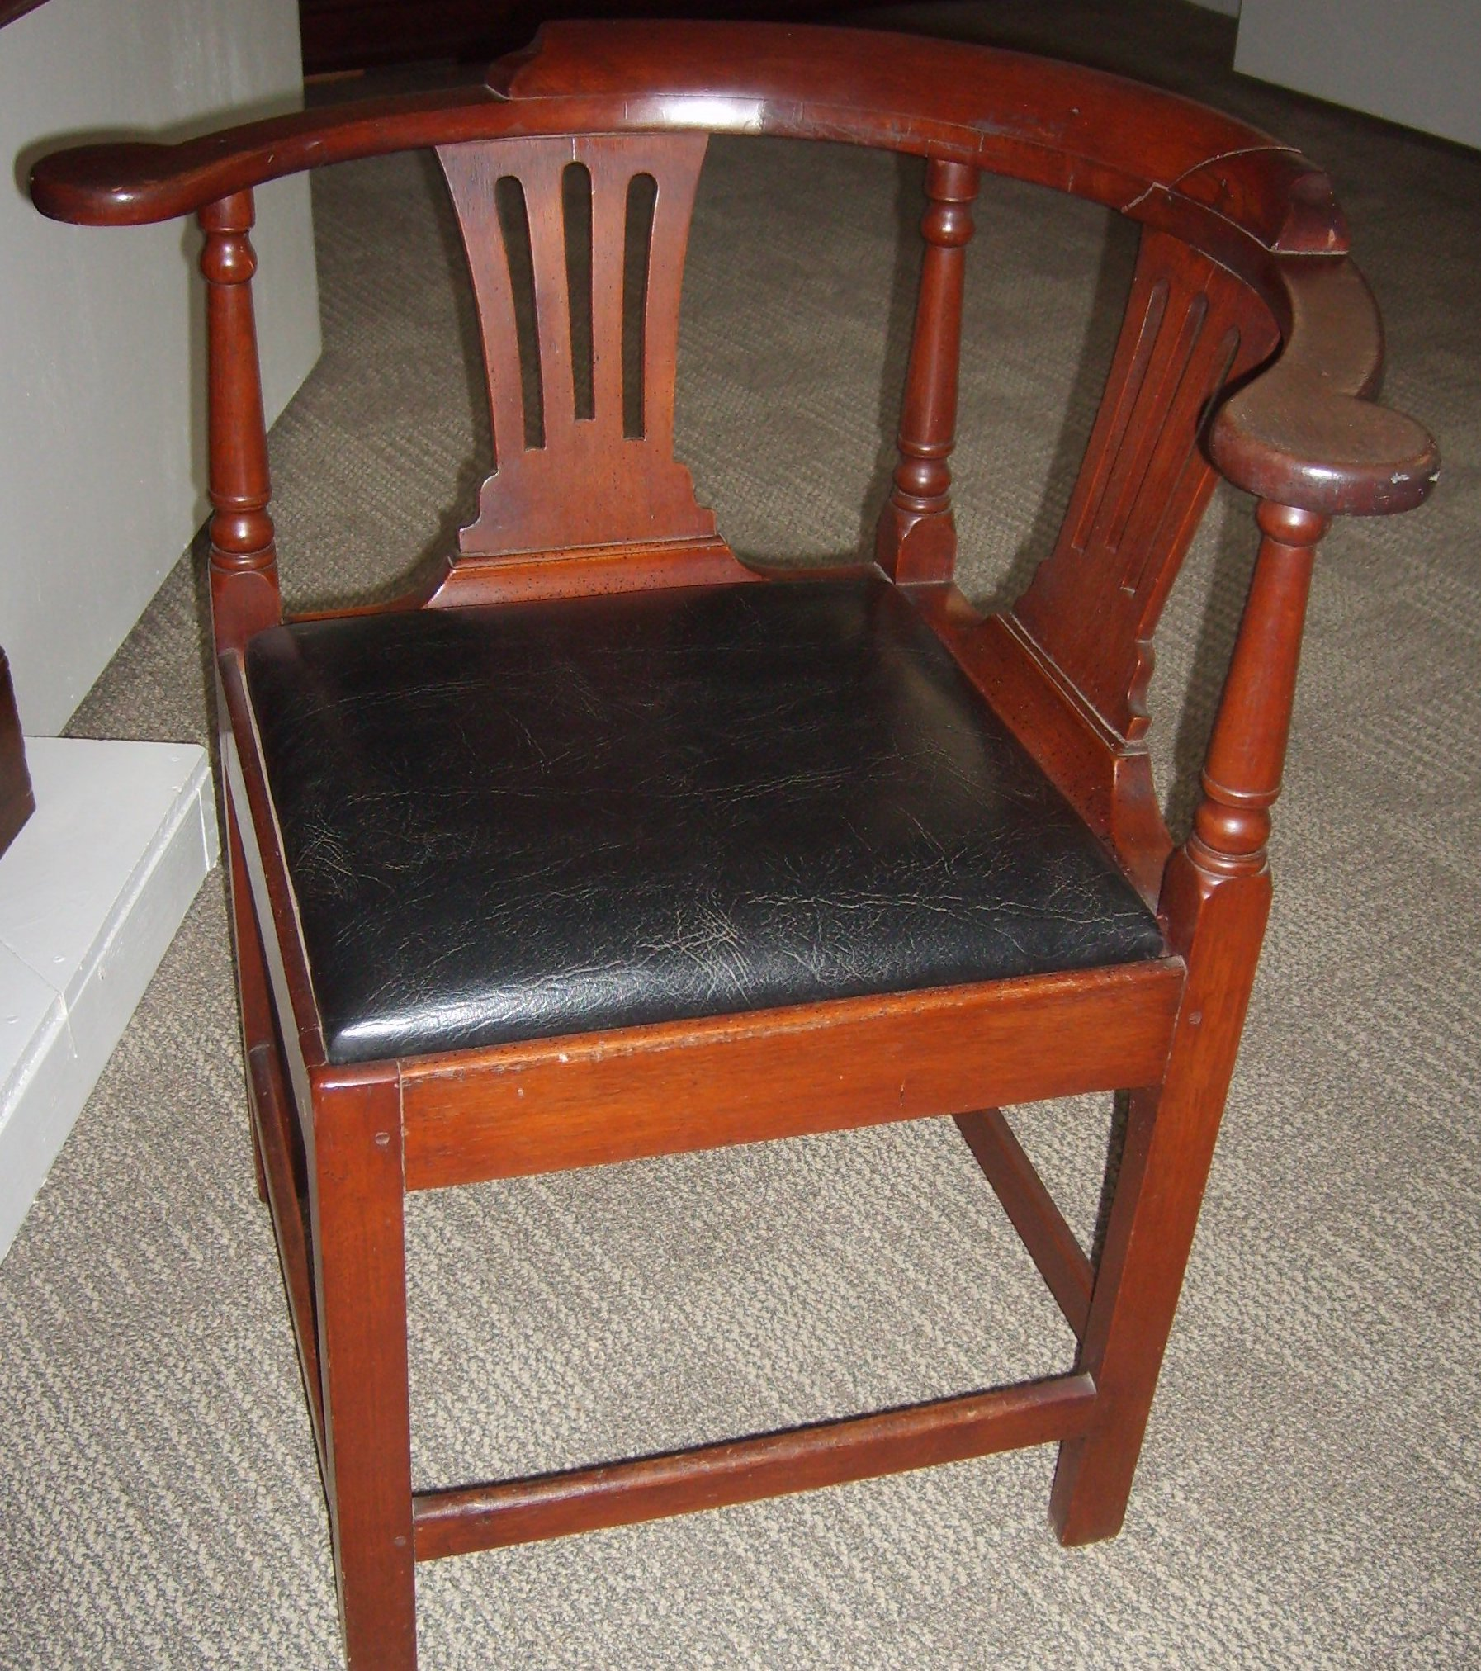
Corner chair,
c. 1740-1770

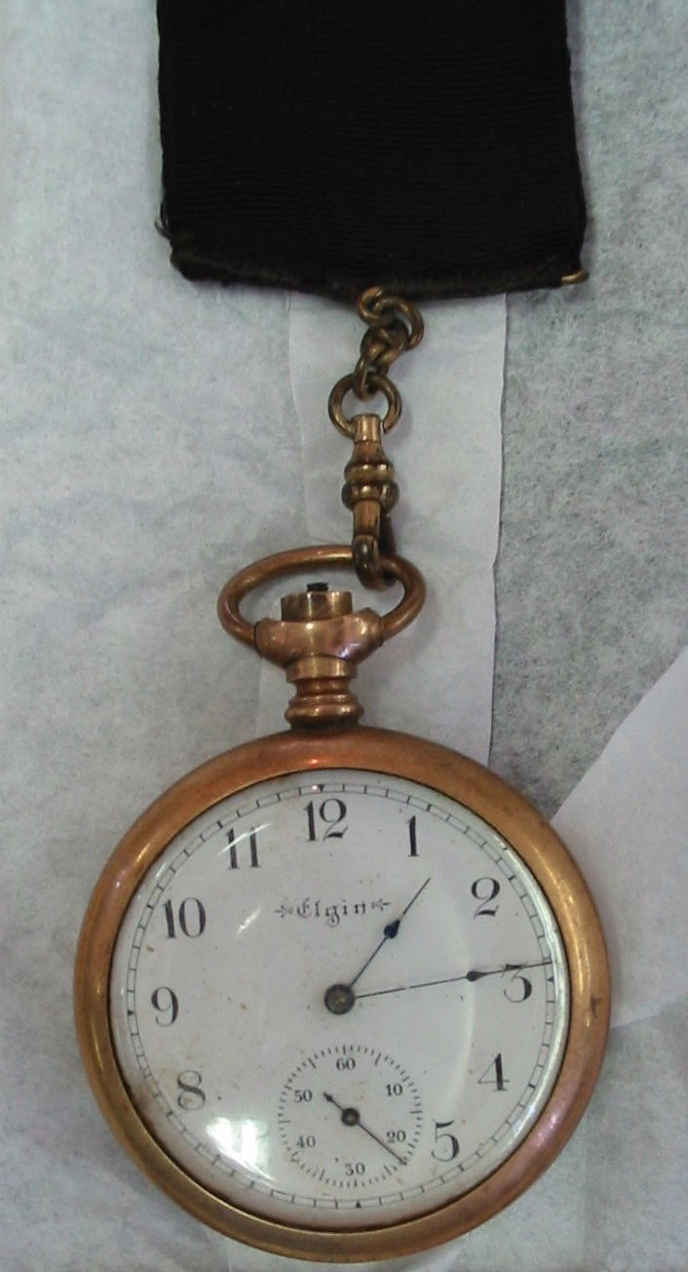

Pocket watch

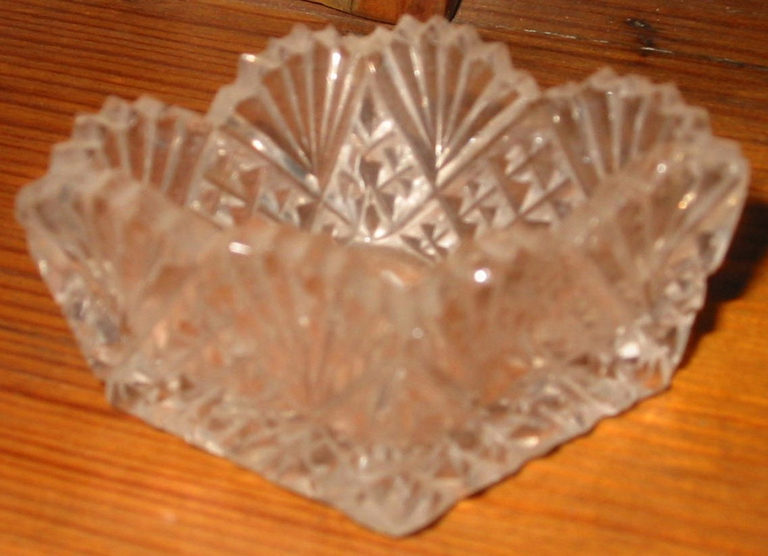

Salt dish, c. 1876-1906

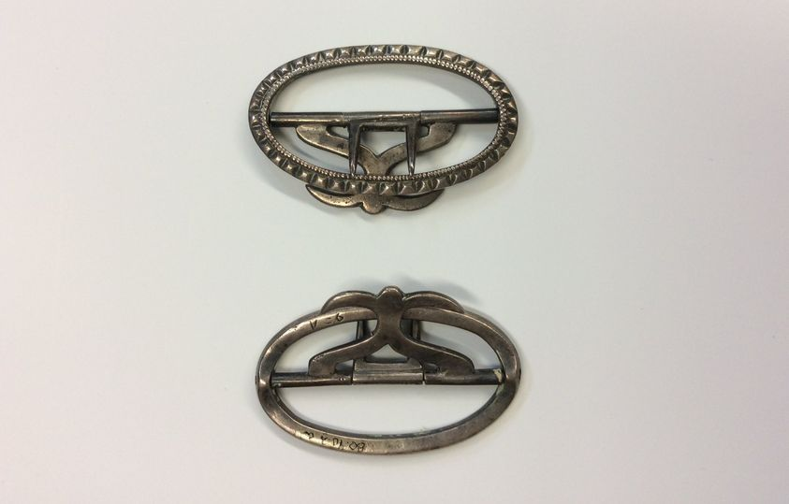
Knee buckles, c. 1752-1790

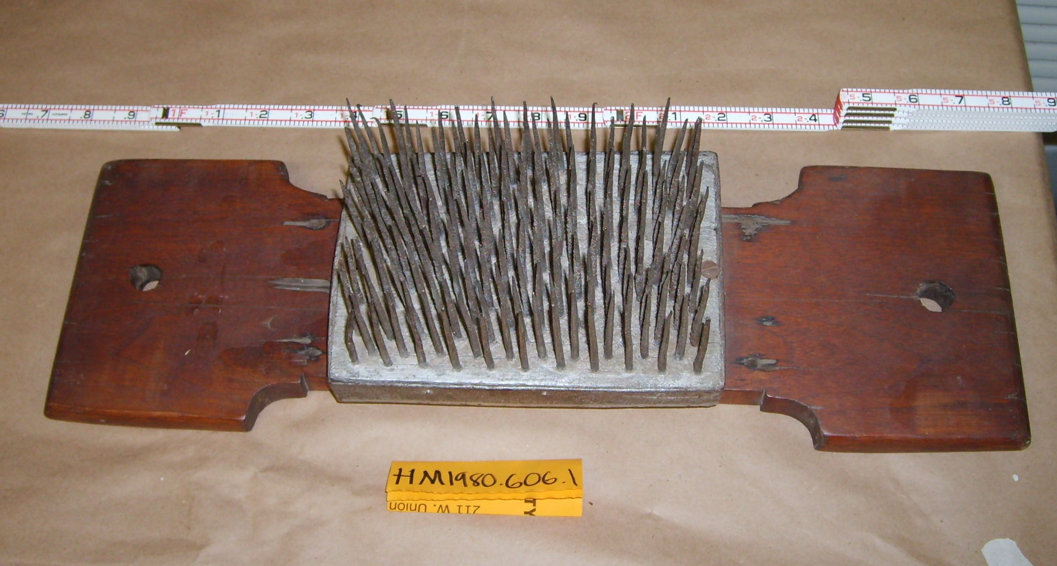
Hatchel used for ‘combing’/separating flax fibers

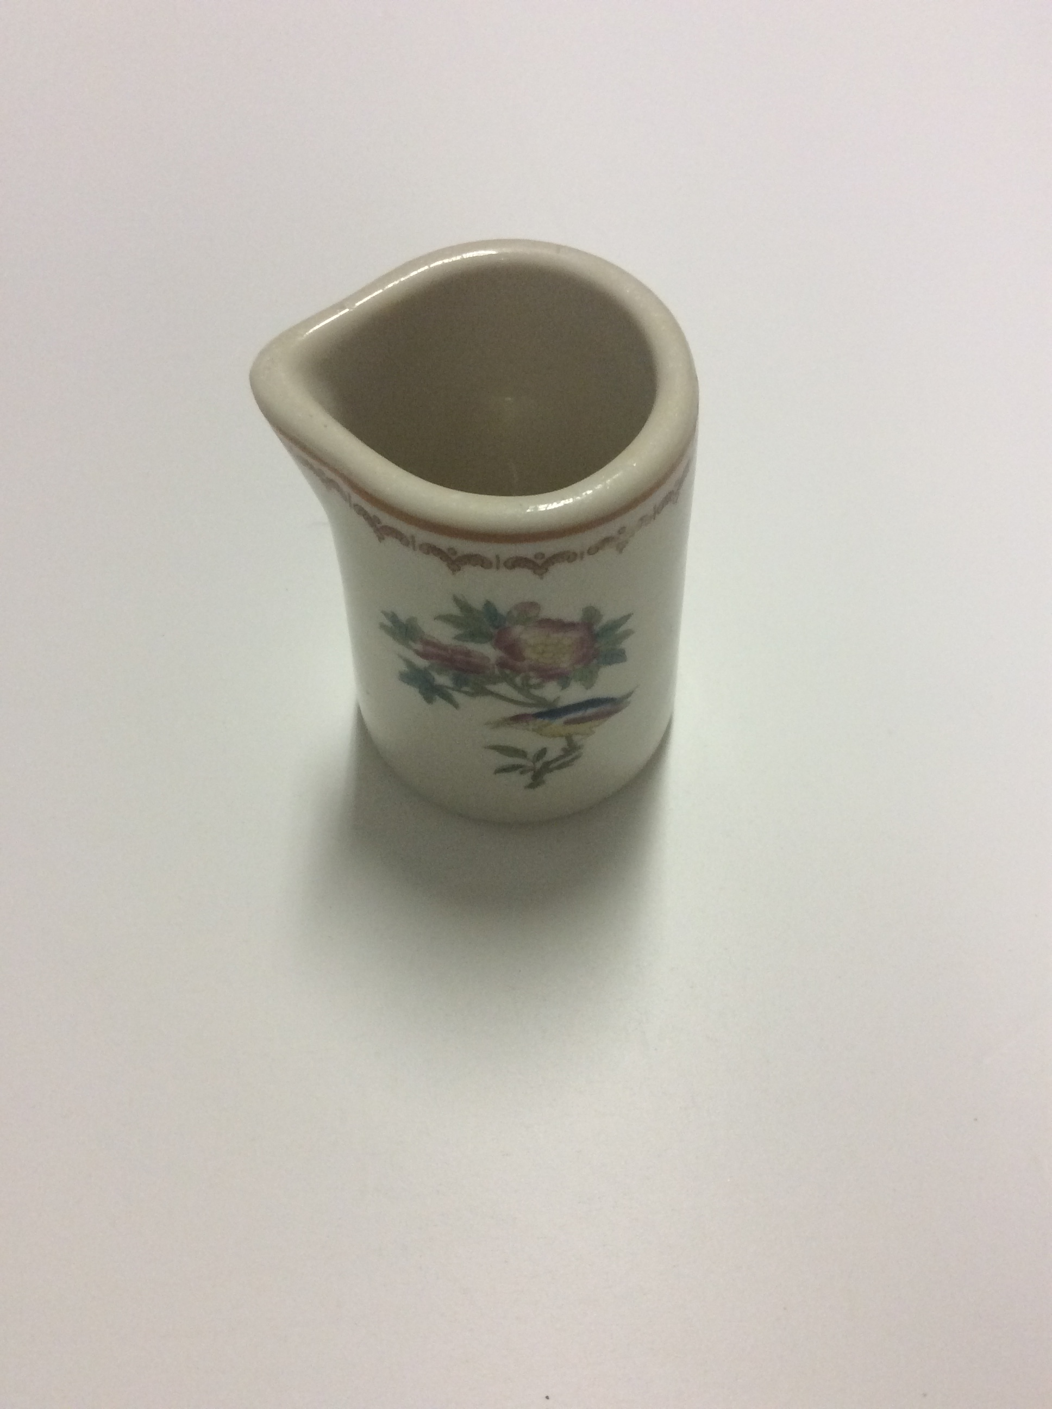

Creamer, c. 1930-1970

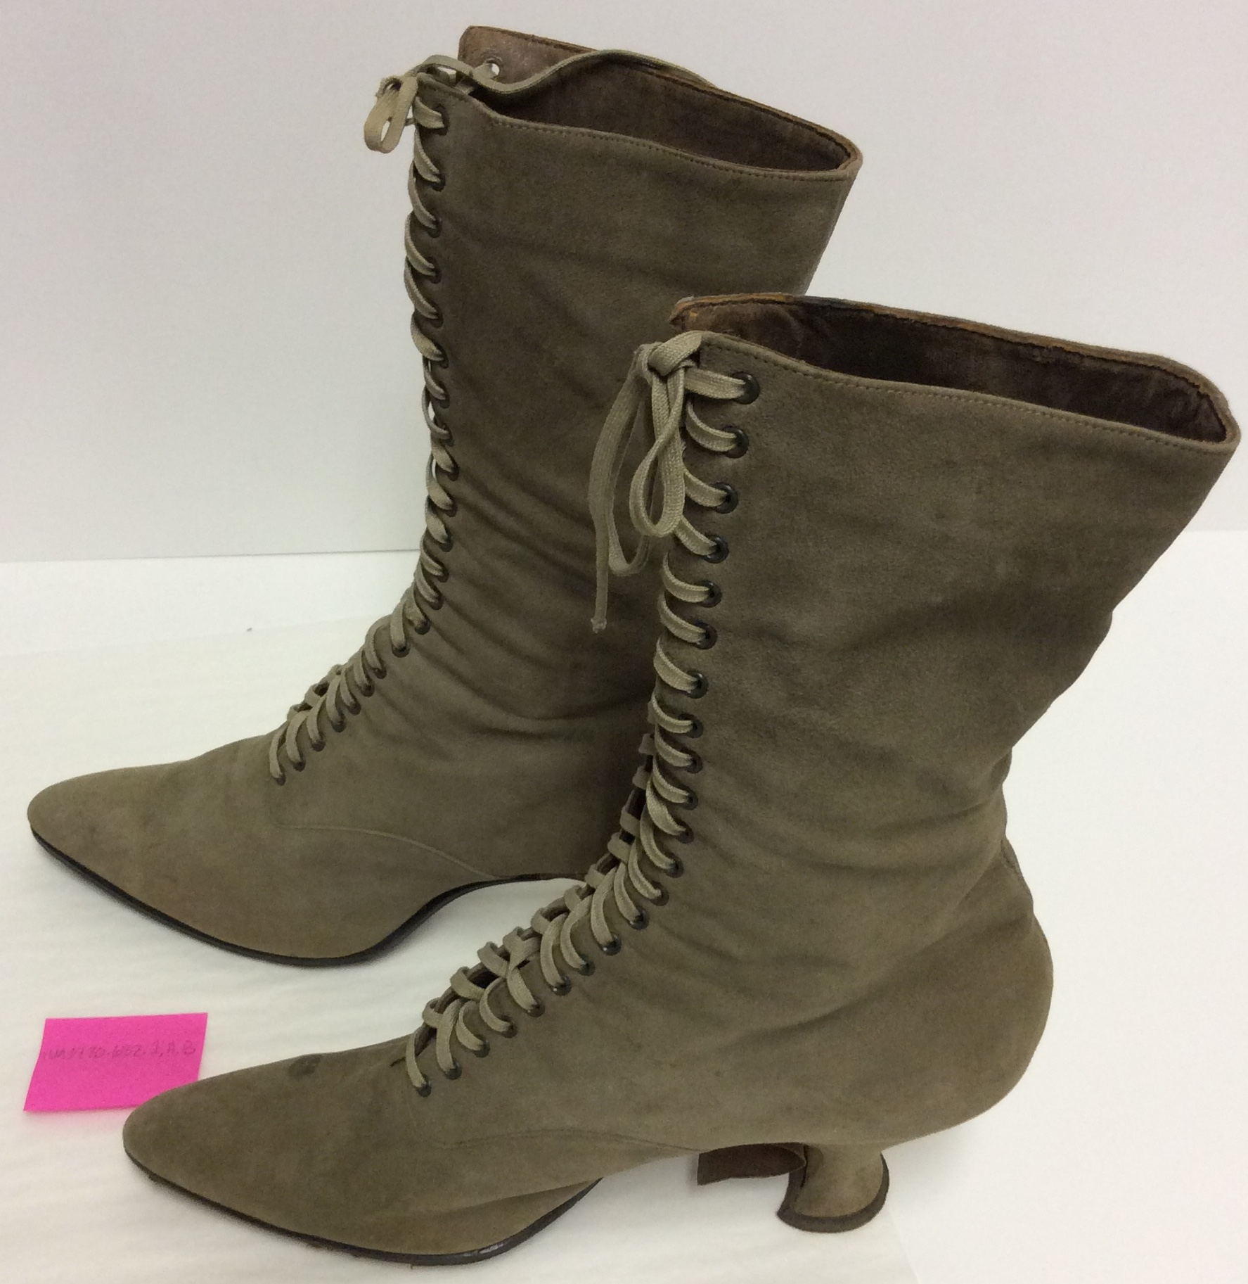
Suede boots, c. 1915

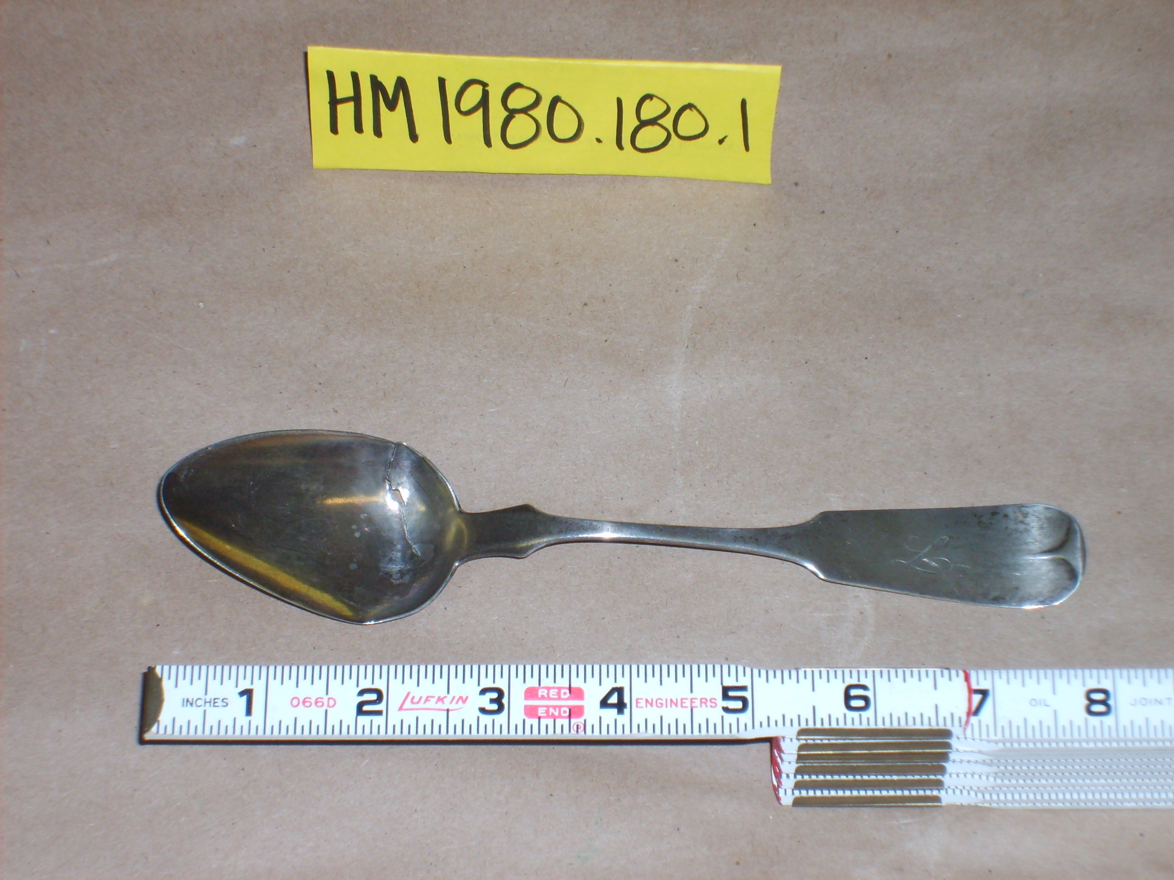
Silver tablespoon, c. 1830-1835

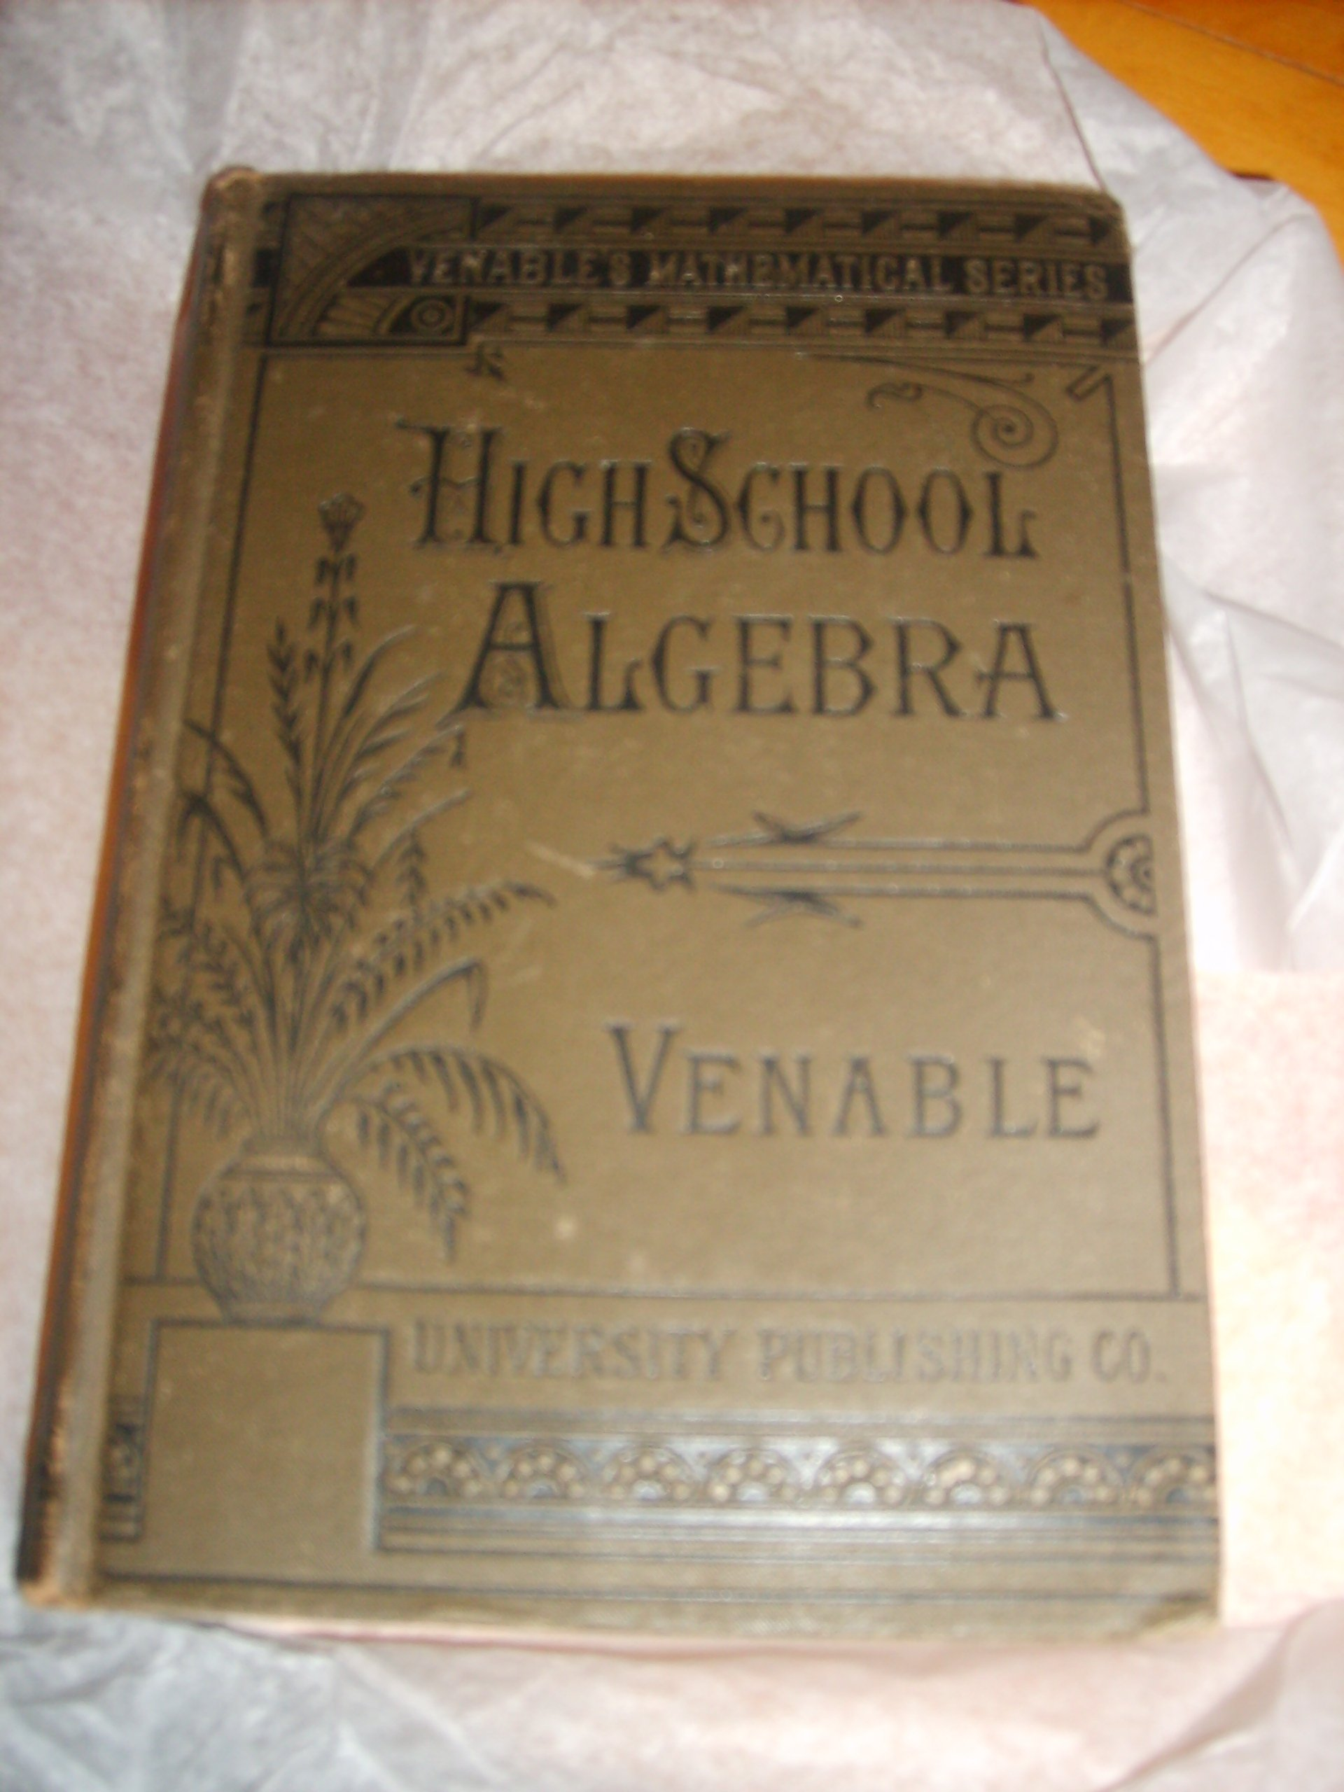
High school algebra textbook, c. 1888

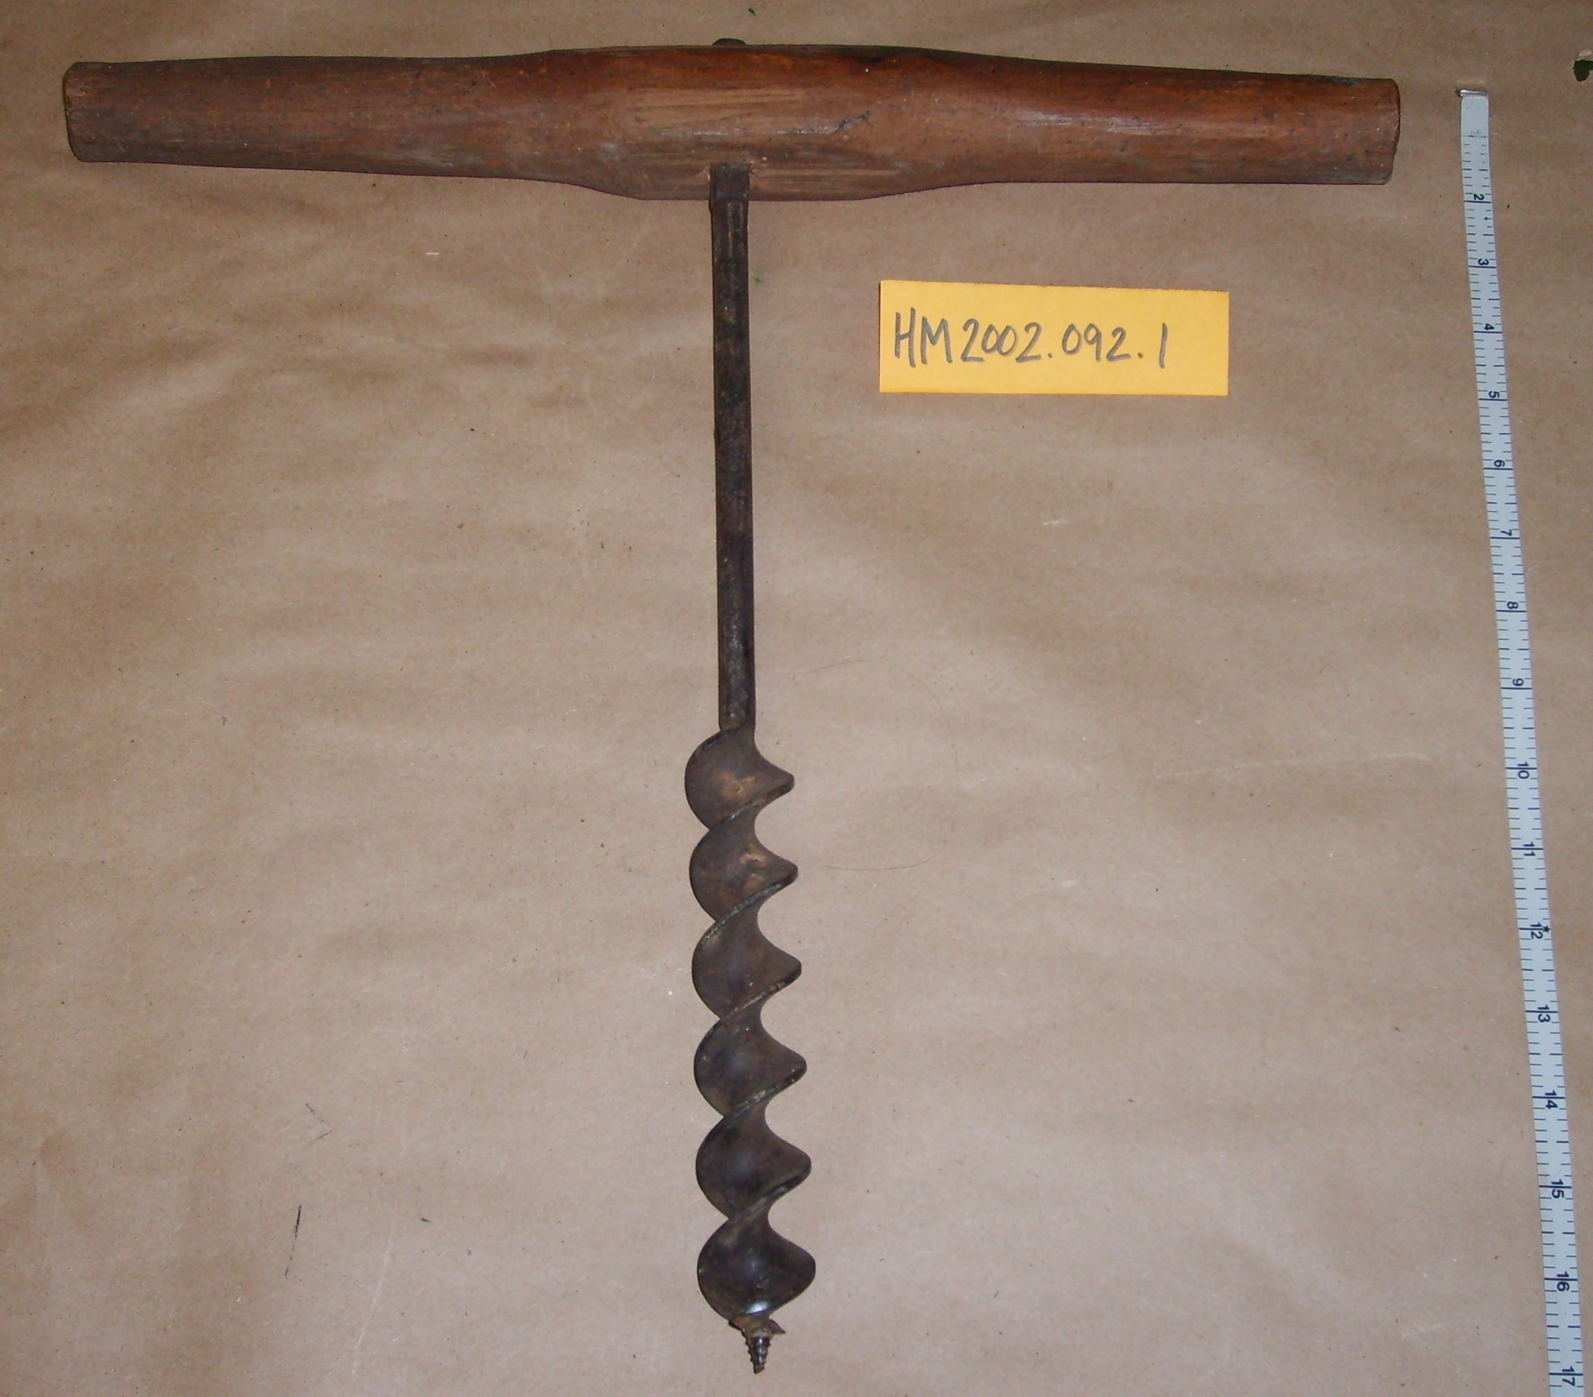
Spiral auger, c. 1850-1900

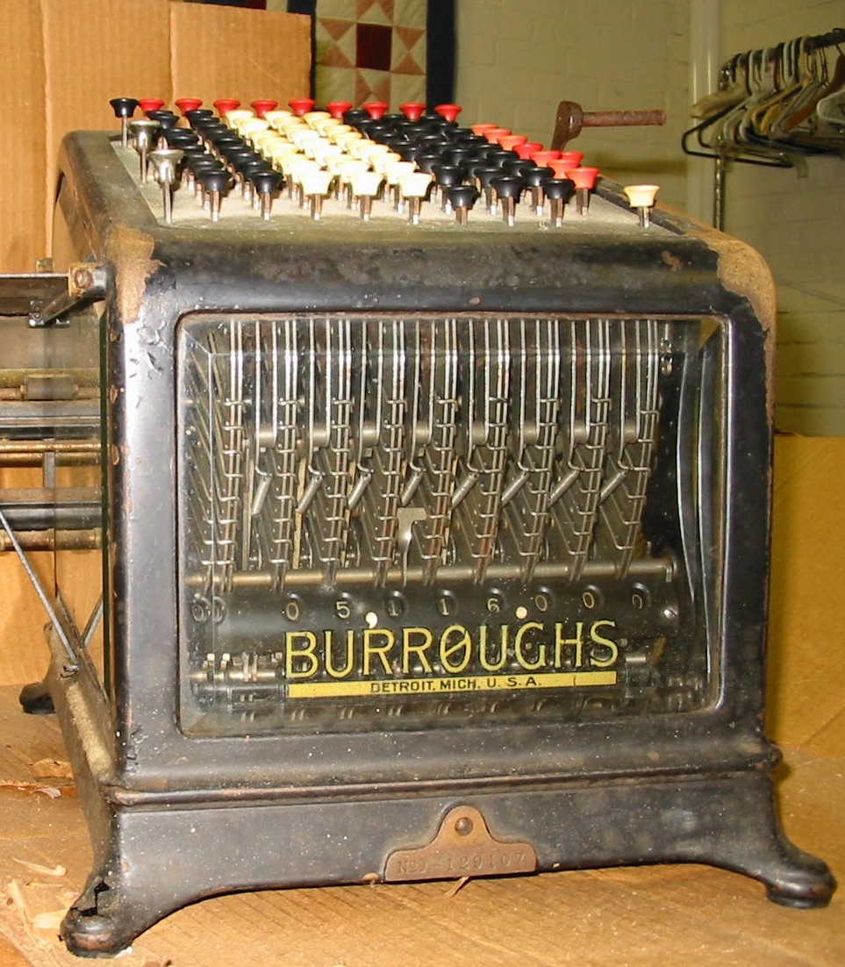

‘Comptometer’-sophisticated adding machine C. 1908-1912

